

YEAR: 8
2016
SUBJECT: Science

Test: Microscopes

TIME: 60 minutes

QUESTIONS: Section A: 12 Multiple Choice (12marks)
Section B: 5 Short Answer (22 marks)
Section C: 1 Long Answer (10 marks)

TOTAL MARKS: 44 marks

PLEASE DO NOT WRITE ON THIS BOOKLET

SECTION A. Multiple Choice Questions
This section has 20 questions. Answer all questions on the separate multiple-choice answer sheet provided.

- At school, what is the name of the equipment used to look at cells?
- stereoscope
- electron microscope
- telescope
- light microscope

- The magnification of the microscope tells you
a) how big the lenses in the microscope are
b) how much smaller the image is than the real object
c) how much bigger the image is than the real object
d) how much light is passing through the object

- Which of the following is the smallest unit of length?
a) Meters
b) Kilometers
c) Millimeters
d) Centimeters

- A micrometre (μm) is:
a) one-thousandth of a millimetre
b) one-hundredth of a millimetre
c) one-thousandth of a centimetre
d) one-hundredth of a centimetre

- As the magnification increases, then the field of view
a) gets smaller
b) gets bigger
c) stays the same
d) doubles in size

- When looking through a microscope, if you move the slide to the right, the specimen appears to move to the
- right
- up
- left
- down

- When carrying a microscope, what is the safest part to hold?
- stage
- arm
- mirror
- tube

- Which of the following is NOT a part of animal cells?
- nucleus
- cell wall
- cytoplasm
- cell membrane

- What is the definition of a unicellular organism?
- a living thing
- a single celled living thing
- more than one cell living thing
- a non-living thing

- What is the purpose of the cell wall in plant cells?
- allow nutrients in and out of the cell
- hold the organelles of the cell
- provide structure and support to the cell
- allows the cell to photosynthesise

- What does a plant cell have that a fungal cell does not?
- cytoplasm
- chloroplast
- nuclear membrane
- cell wall

- Mitochondria, ribosomes, lysosomes and endoplasmic reticulum are examples of
a) organelles
b) chloroplast
c) muscles
d) nuclear membrane

Safety Bay Senior High School
Science 8 – Microscope Test

Name: _______________________________________________

Section A: Multiple Choice Answers

Put a cross (X) through the correct answer.

1 a b c d
2 a b c d
3 a b c d
4 a b c d
5 a b c d
6 a b c d
7 a b c d
8 a b c d
9 a b c d
10 a b c d
11 a b c d
12 a b c d

Marks

Section A: Section B: Section C:
Multiple Choice Short Answers Long Answer Total

/44

/22

/10

/12

Short Answer Section

- Label and write a brief purpose of each part of the microscope.
(7 marks)

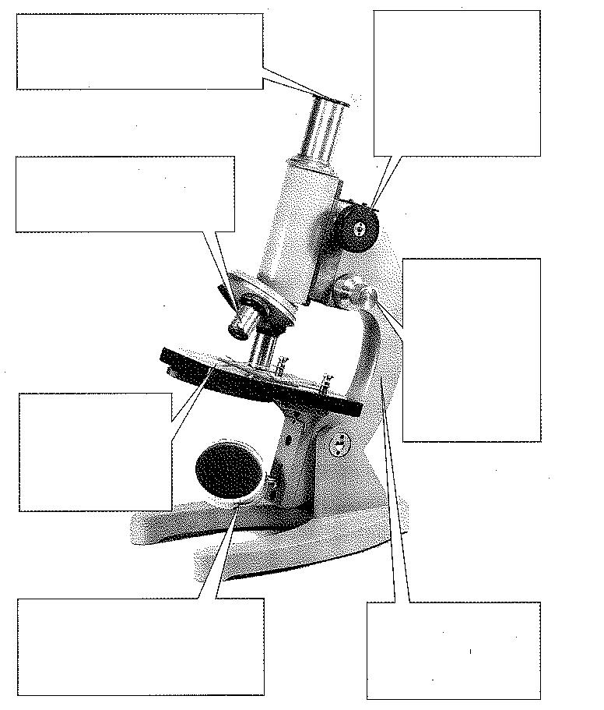

- Complete the following: (4 marks)

a) Name the two parts that you would hold to carry the microscope safely
______________________________________________________________

b) Name the part you place the slide on
______________________________________________________________

c) Name two microscope parts that magnify the slide
______________________________________________________________
d) Name two microscope parts that allows a slide to be focused
______________________________________________________________

- Use the diagram to complete the following questions

A
B
C
D
E

- Match the organelle names with the correct letter from the cell diagram (5 marks) vacuole, mitochondria, nucleus, cell membrane, cytoplasm

Label | Organelle
A
B
C
D
E

- Is the diagram of a plant or animal cell? Explain? (2 marks)
____________

- With the aid of a diagram explain what would happen to the letter ‘e’ if viewed under a microscope (4 marks)

SECTION THREE: Long Answer
Explain fully how you would use a microscope when focusing on an object. Include all safety considerations in your answer. (10 marks)

______________________________

______________________________

______________________________

____________

